Kalman Filter

1) A Kalman filter is an optimal estimation algorithm, that predicts the parameter of interest (e.g. location, speed, direction) in the presence of noisy measurements.
It can be used to estimate a system state (variable) when it cannot be measured directly, but an indirect measurement is available.

e.g. Can use KF to find the best estimate of the internal temperature of rocket thrust from an indirect measurement. Since cannot place a sensor inside the thruster you have to place it on a colder surface and measure the temperature here.
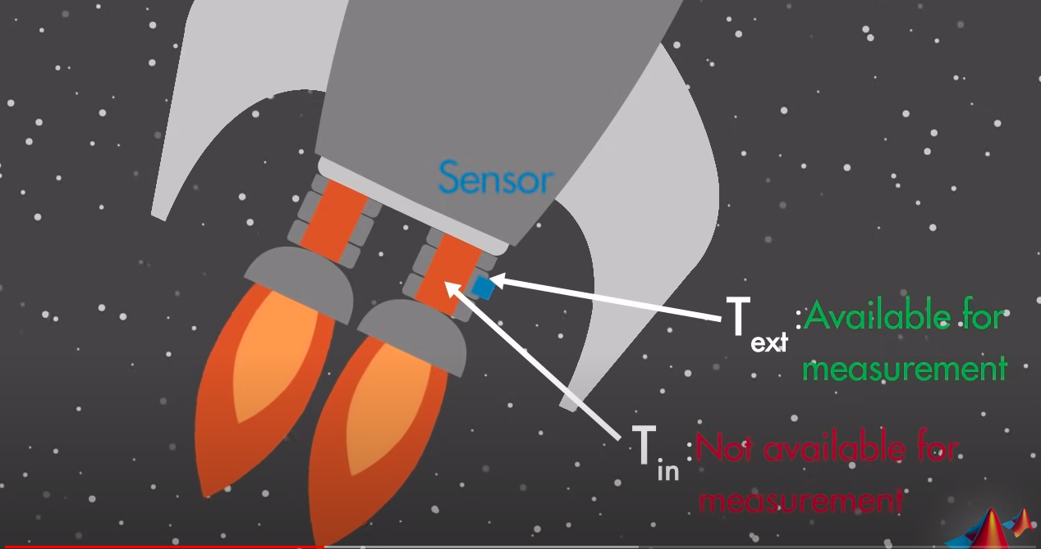

2) Also, KF can be used to estimate a state of the system by combining measurements from different sources (sensors) that may be subject to noise.

e.g. KF used to fuse 3 measurements (IMU, Odometer and GPS) to find the optimal estimate of the exact position of the car.

Common applications of Kalman filters include guidance, navigation and control systems; computer vision systems; and signal processing. One of the first applications of KF was in the 1960s for the Apollo project. It was used to estimate the trajectories of the manned spacecraft to the Moon and back.

KF has 2 steps: Prediction and Correction.

Prediction uses control commands to estimate in order to predict where the system will be at the next point in time. (e.g. If I go 1m/s forward I will be at 1m from here in the next second).

Correction uses sensor observations in order to correct for potential mistakes that we have done.
So it takes the observations into account and compute the so-called predicted observation and compares those two observations in order to perform a correction

So for every new command/measurement we do a prediction step,then a correction step then the new command/observation comes in so a new prediction and correction. This recursive procedure which always updates the previous belief and turns it into the next belief.

The KF makes two assumptions:

The first assumption is that everything is Gaussian, so we are living in a Gaussian world, meaning that the position of the platform is Gaussian and also for example the uncertainty that I have for my motion or observation are Gaussian.

The second assumption is that all the models are linear.

If we are in a Gaussian linear world, the KF is the optimal estimator so you can’t do better in order to estimate the state of a dynamic system.
If you are living in a nonlinear world, which is actually the case, then the KF can’t be used anymore. But you can use a so-called Extended Kalman Filter (EKF) which is a variant of the KF that tries to deal with these nonlinearities. It performs a local linearization so it performs a Taylor approximation (Linearization via Taylor) of your nonlinear models and turns them into linear models given your current linearization point. So you need to recompute this linearization at every step because you will have a new initial guess so a new linearization point. But then it actually works in the same way as the KF does. It just adds this local linearization to that.

The KF as well as the EKF is a very popular state estimation technique. It’s one of the really basic probabilistic recursive based filters and is used in large number of different applications (e.g. Localizing a vehicle in the environment or tracking the position of a camera).

All those state estimation techniques which update the belief of a system giving new data uses those probabilistic state estimation techniques and the KF is one of those basic approaches in order to do that.
_______________________________________________________________________________

State Observers (helps explain what KF are and how they work)

State observation helps you estimate something that you can’t see or measure directly.

Need to use a state estimator to estimate your internal states. Let’s see how a state estimator works:
Here our goal is to match the estimated external temperature with the measured external temperature.
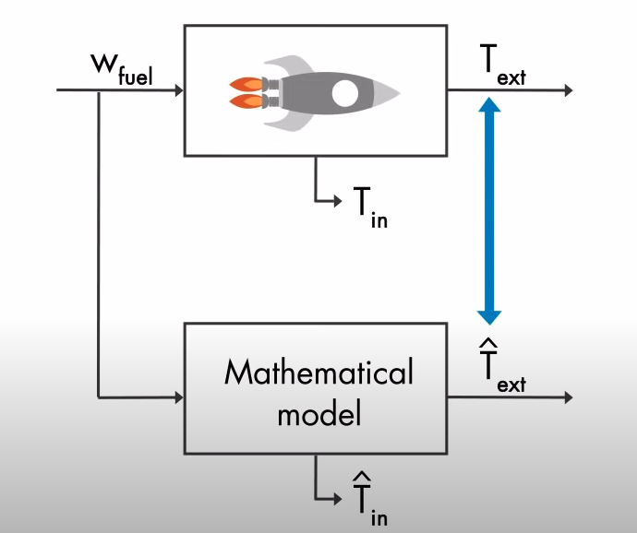

The goal is to estimate the difference between Text and T’ext so that Tin converges to T’in.
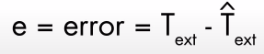
Actually we are talking about a feedback control system, where we try to control the error between the measured and estimated external temperature at zero using a controller K.

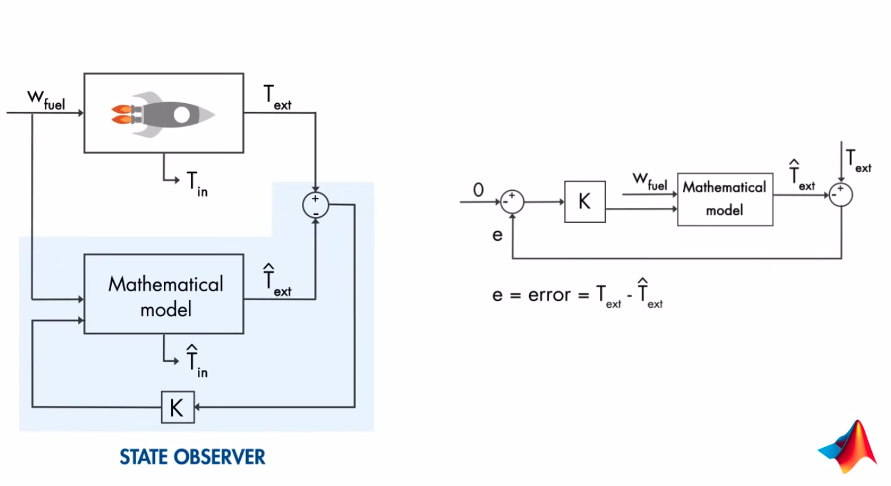

By closing the loop with the controller K around the observer, we try to eliminate the error between the estimated and measured external temperature such that the estimated internal temperature is driven to its true value.

In summary, you can’t directly measure the internal engine temperature. But you know how much fuel you’re supplying to your rocket, so you can run this through your mathematical model and estimate the output, which you can then use along with your real measurement to estimate the internal state of the system.

The question is how to choose the controller gain K such that the eror between the measured and estimated external temperature is minimized optimally. (next video explained)
Now, we’ll explain the state observer mathematically. We’ll generalize the problem and show the input as u, the output as y, and any states we want to estimate as x.
Our goal is to drive x’ to x, so we can define the difference between these values as an error
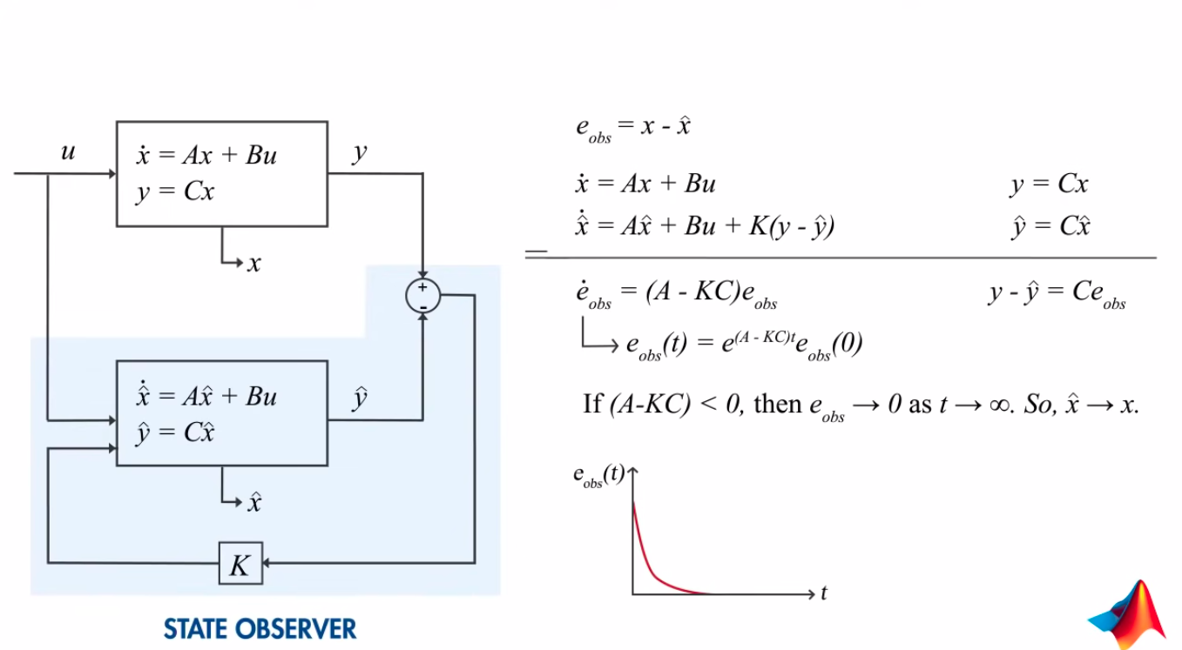
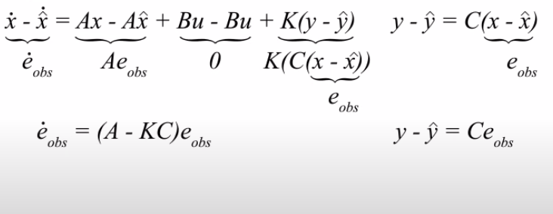

An optimal way of choosing the gain K is performed through the use of KF

